Funnel clouds spotted amid thunderstorm
By: Colin SlarkPosted: 3:00 AM CDT Friday, May. 12, 2023
Funnel clouds formed over Hamiota during a thunderstorm Wednesday afternoon, Environment and Climate Change Canada has confirmed.
The clouds were seen around the time a tornado warning was issued for parts of Westman around 4:30 p.m. that day.
Despite the warning, Edmonton-based meteorologist Sara Hoffman told the Sun evidence received from residents of the area don’t suggest so far that a funnel cloud touched down.
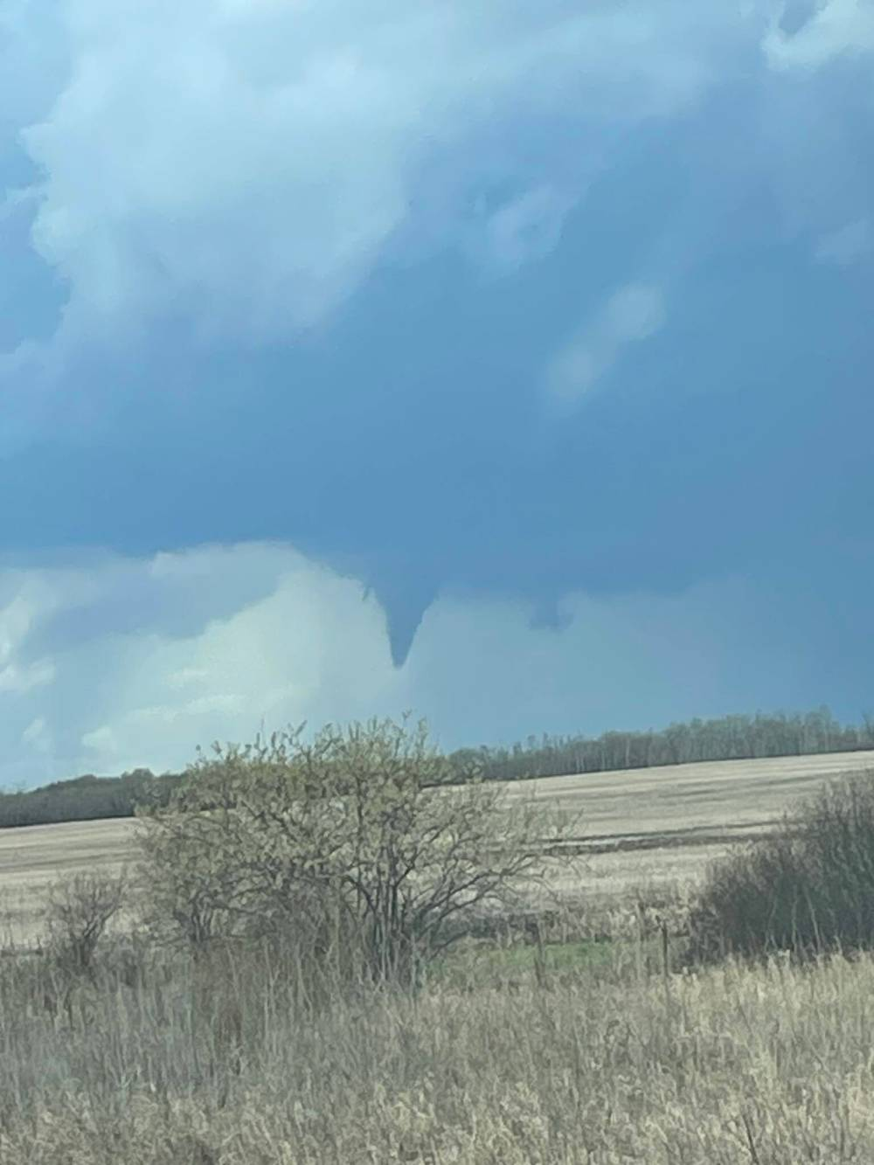
This photo provided by Westman Storm Chasers shows a funnel cloud spotted over Hamiota on Wednesday afternoon. (Submitted)
“There was a storm in the area that was conducive to creating tornadoes. That’s why the warning went out,” Hoffman said.
The difference between a tornado watch and a tornado warning, she said, is the likelihood of occurrence.
“A watch means that all the conditions are there and it’s possible. A warning means it’s imminent or occurring,” she said. “In the case of this storm, we had a very large supercell thunderstorm that we could see on radar that had a lot of signatures that made it conducive to creating a tornado.”
She added that those alerts aren’t issued lightly. If someone is in an area subject to a tornado alert, Hoffman recommended people remain in their homes, move away from windows and into a basement if possible.
Under stairs and in bathrooms can also be safe places. Automobiles are not considered safe as tornadoes can lift them off the ground.
On top of the clouds, she said the storm also produced golf ball-sized hail in some parts of Manitoba.
Though it’s only May, Hoffman said Wednesday’s storm signals the start of the severe summer weather season for the Prairies.
Westman Storm Chasers told the Sun they were tracking the storm and believe from the photos they took that a funnel cloud did in fact touch down.
“We intercepted it just south of Hamiota and there was already a large funnel cloud on the storm,” Mandi Grayston wrote in an email.
“I was editing my photos last night and noticed some of them show the funnel touching down. I have submitted a report to Environment Canada and provided them with as much information as possible. It will be their final decision on it. Touchdown was likely fairly brief.”
If someone sees what they think is a funnel cloud or tornado, Hoffman encourages them to contact Environment Canada to provide a description and photos of the event.
To do so, Manitoba residents can either call 1-800-66-STORM (667-8676) or email mbstore@ec.gc.ca.
As of Thursday afternoon, Brandon’s seven-day forecast from Environment Canada was not predicting any thunderstorms within the next week but listed a 40 per cent chance of showers on Saturday.

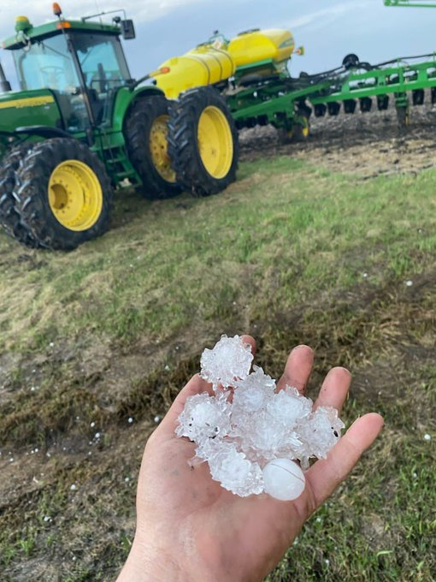
5 miles east of Morris along highway 23 https://twitter.com/antara_jenn/status/1656478743072759809

yanlafond @yanlafond·May 10
I got some nickel size hail. East side of red river between st Jean and Morris.
https://twitter.com/yanlafond/status/1656500393235435520
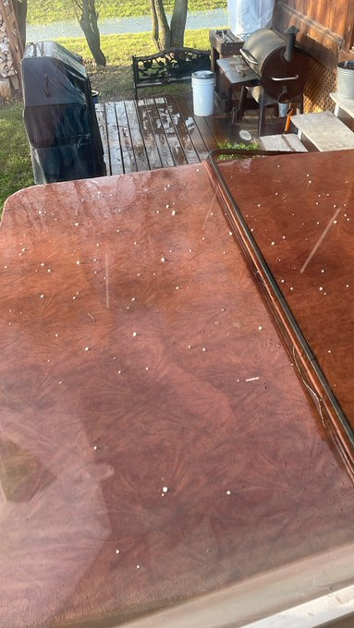
St Jean (same link as previous photo)
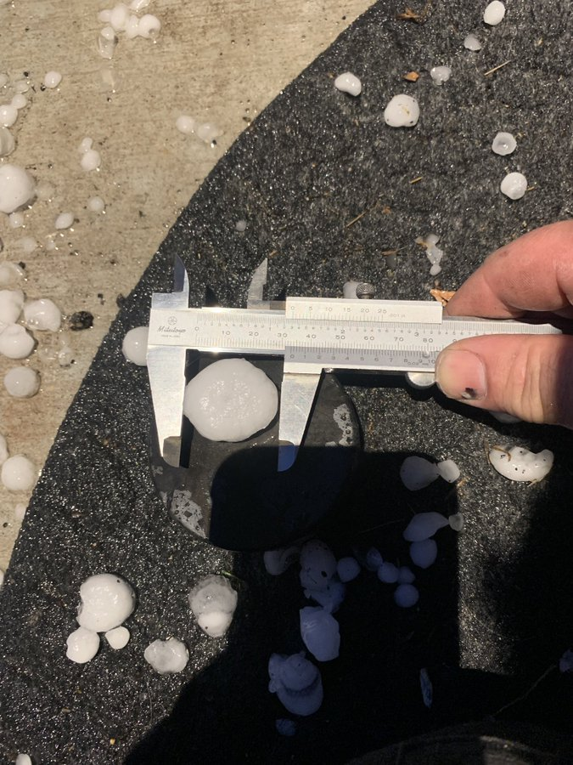32mm hail Grunthal dan fetter@danfetter78
https://twitter.com/danfetter78/status/1656480530500579331

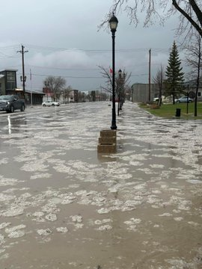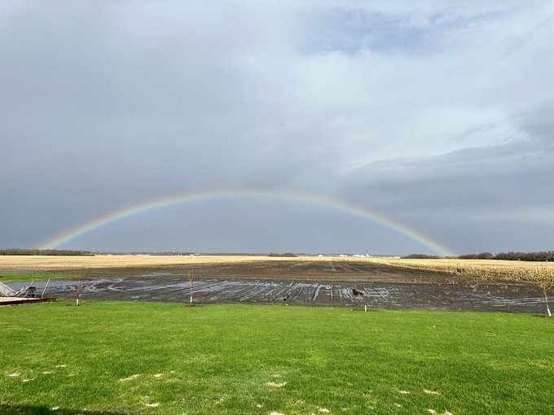
Both above from Ste Rose 5-530 pm Robert Brunel @rpbrunel
https://twitter.com/rpbrunel/status/1656504924610650112
Hail size: Largest would have been 1/2”. But majority was small
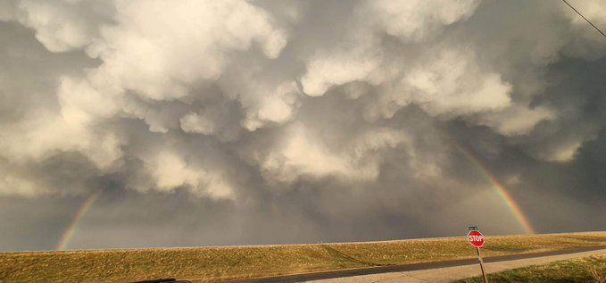
Kimberly Rae Jordan@KimberlyRJordan·May 10
Taken along Birdshill Road facing east.
https://twitter.com/KimberlyRJordan/status/1656475639992442881

@scottdkehlerMy garden got pummelled, but at least my dog has ice water . Large volume of 6 to 13 mm hail 2 miles south of deacons corner.
https://twitter.com/scottdkehler/status/1656473400259276802
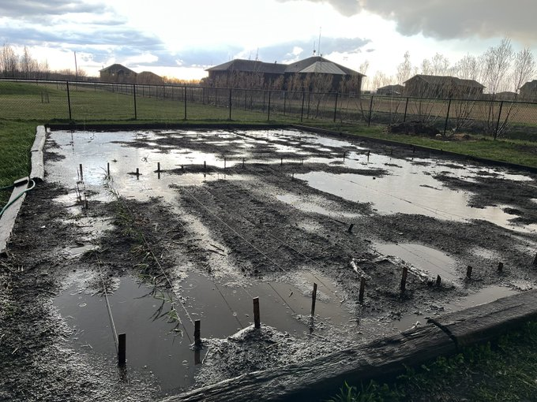

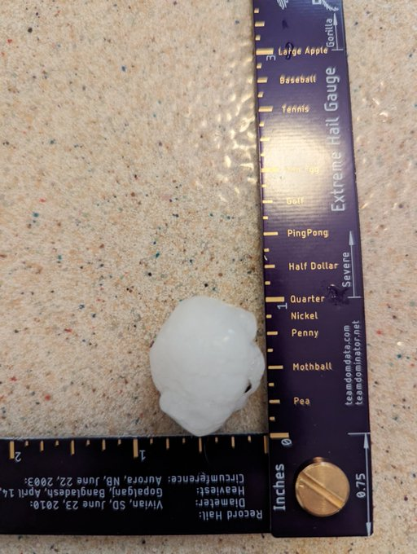
Suzanne Pothe@Spothe·May 10
We got hammered with hail in Fort Richmond
https://twitter.com/Spothe/status/1656466445927342080

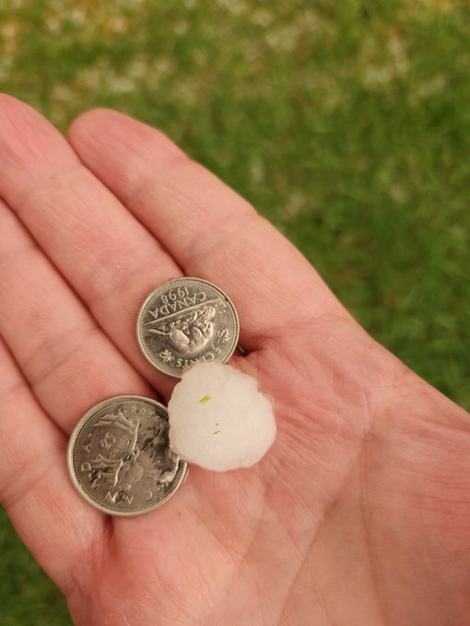
Dave Carlsen@StormStructure·May 10
Nickels fell in South Pointe Winnipeg at 7:57 pm
https://twitter.com/StormStructure/status/1656468876270481409

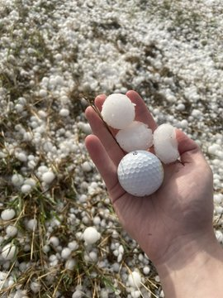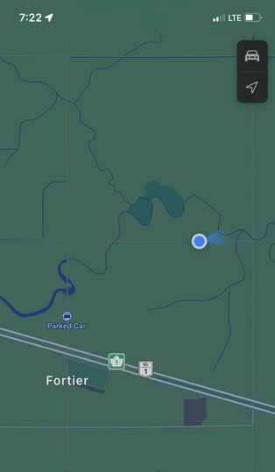

Michael Nowak@MichaelNowak123·May 10
Largest I’ve found so far. Fortier, Manitoba

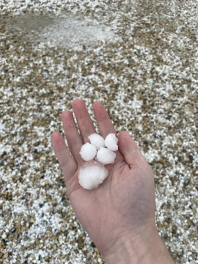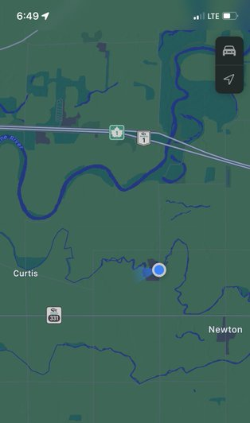
Michael Nowak@MichaelNowak123·May 10
More quarter size hail covering the road here, creating lots of hail fog. Quite an amazing view! It’s clear there has been lots of melting, I would guess initially the hail could have been up to about 30mm in diameter.
https://twitter.com/MichaelNowak123/status/1656447274463920129

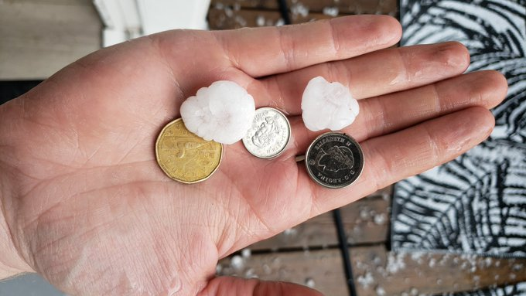
Crawford Luke@cluke5·May 10@ECCCWeatherMB
I just had plenty of dime to loonie size hail (18-26 mm) by Polo Park. Some of the larger ones were slightly larger. Hail fell at my location from 2335z-2337z (6:35-6:37 p.m. CDT).
https://twitter.com/cluke5/status/1656444331924811776

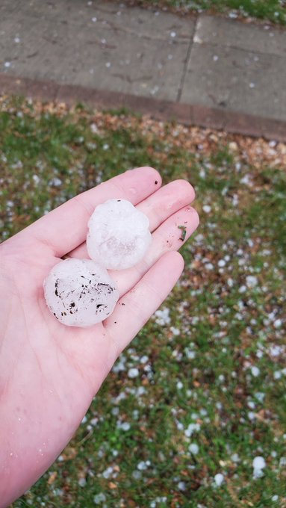
elishadacey @elishadacey·May 10
St james, toonie sized, but most of it is quarter sized
https://twitter.com/elishadacey/status/1656443890986102785

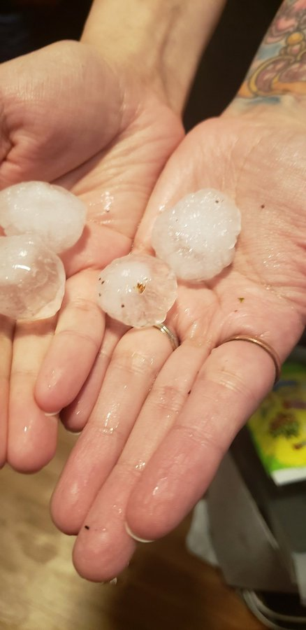
Tim Wilson @Computim·May 10
Quarter sized hail just south of YWG Winnipeg Airport!

https://twitter.com/Computim/status/1656445222534914051
Brad Hignell@moworhead·May 11
Near Portage and Dominion.
https://twitter.com/moworhead/status/1656643697545543681

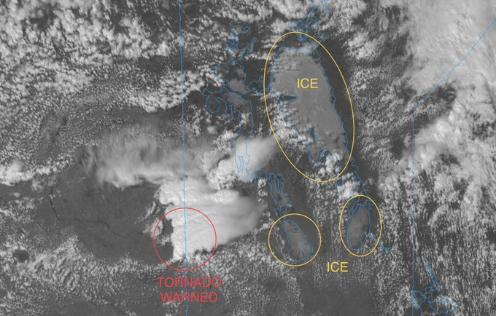https://twitter.com/vaughanweather/status/1656394366619901954
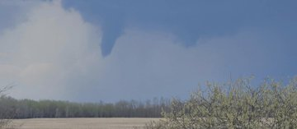https://twitter.com/Spothe/status/1656407696076324864
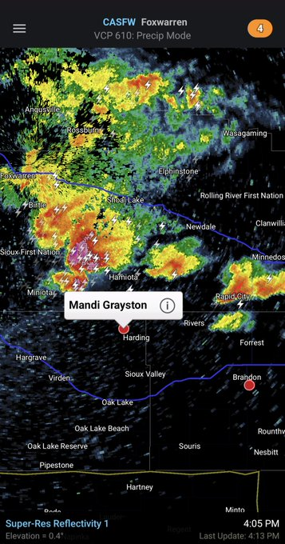

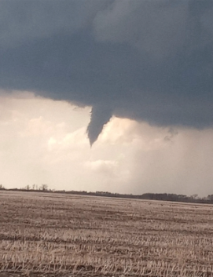
Chanesty M. share pictures from #Hamiota of a funnel cloud that her friend just posted via Facebook 434pm
https://twitter.com/IWeatherMB/status/1656412431382376451

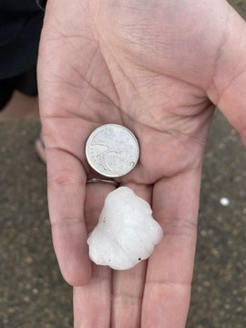
Matt Desorcy@lovestormsMB·May 10
Toonie size hail between Macgregor and Bagot MB. Probably already melted for 5-10 minutes.
https://twitter.com/lovestormsMB/status/1656441889581588482

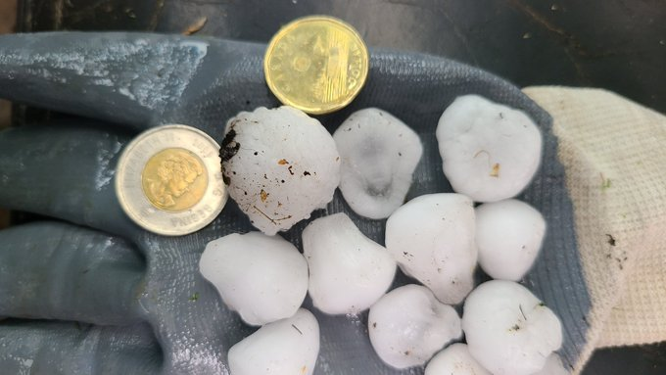MacGregor area by Judi Watt @JBMEquiFarms https://twitter.com/JBMEquiFarms/status/1656437650176327681

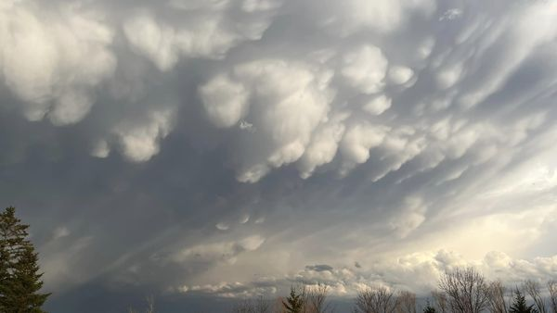
Over Winnipeg behind storm
https://www.facebook.com/groups/605744407196622/posts/899111734526553/?__cft__[0]=AZXStzfYAMWIyebrDoZGKhA1kWp35ZuFbSabTCs5R7Nd8jze4v_2Zjw5JypzyB6SAlmUIckHEBzWYyh1ckr1ShM6gSOT3tmQW18V7tRVe-02KJXlVCfB_mni9SNVBirVjBbkYUTqdXiQOA45MmpJCngxwgpFgvtRo78tRAXSfsNwk4GvJNR_vFty531o1PYpcmg&__cft__[1]=AZXStzfYAMWIyebrDoZGKhA1kWp35ZuFbSabTCs5R7Nd8jze4v_2Zjw5JypzyB6SAlmUIckHEBzWYyh1ckr1ShM6gSOT3tmQW18V7tRVe-02KJXlVCfB_mni9SNVBirVjBbkYUTqdXiQOA45MmpJCngxwgpFgvtRo78tRAXSfsNwk4GvJNR_vFty531o1PYpcmg&__tn__=%2CO%2CP-R]-R

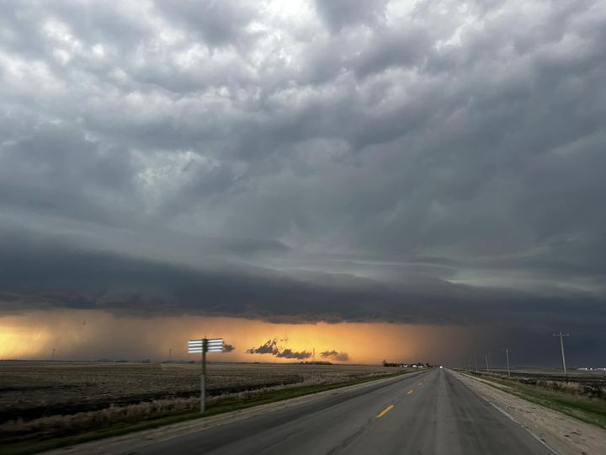Alea Ell
·
Over Landmark/Lorette
https://www.facebook.com/groups/605744407196622/posts/899108067860253/?__cft__[0]=AZWExFNKcnPo_zM_U4cBm7Il3pzo8gULiMq5bxwE0MY3yjroYas_GAvF07Yr_5g-eEagLl1J1UtugenoIxlXHlRh7fu3e3bSPSYdhWOolAxEIenC6VvPOpawEPjQi4mOJ6BsozUj67eYzQElBdUNby4t6mXF3CEzt0aDjPFS8lzJCiLg4XgddqaO0em19K_VvMk&__tn__=%2CO%2CP-R

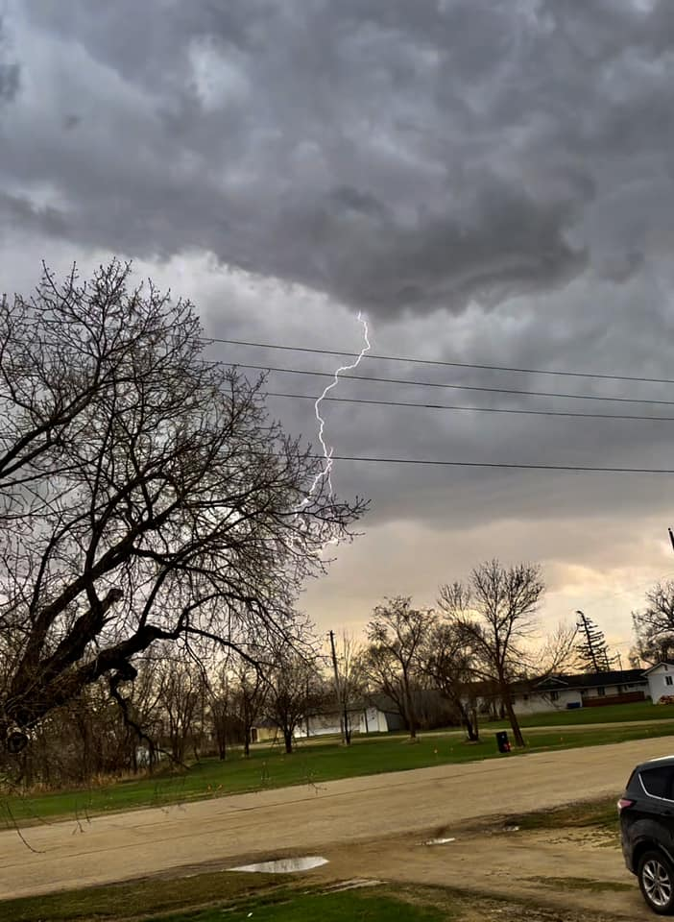Westbourne Corinne Angell
onpoSersdt7t 08M3116t06ay5 3 9a0l73m2033P52t6a9:M1cmf989 34u ·
https://www.facebook.com/photo.php?fbid=10160291808736335&set=p.10160291808736335&type=3

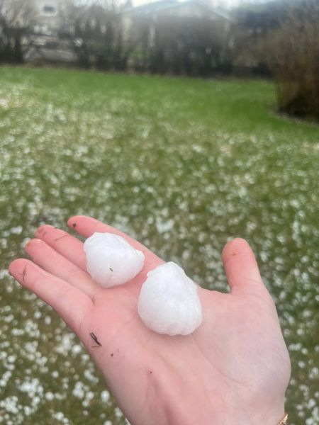Kenna Hannah
·
Ping pong ball sized hail in MacGregor
https://www.facebook.com/groups/605744407196622/posts/899074557863604/?__cft__[0]=AZWW5zPVogJgEV4psWvmt_6sbqCq0KnRaTMjIv3KzfIjr5tQVUJoMb2FGJ-7GO4fut1ZcO9RiDjJWYNm_BGnjlSZy_FpMYPL4BO1r3T0GPzUO65P0InKDSH1Z4RlG0wWQafMYMe4xhrGHDOWwcSQcl2yRWfqwnGHgDWzZK1a6W2TNMUjyOwESNIhJfER5o4Zklc&__tn__=%2CO%2CP-R

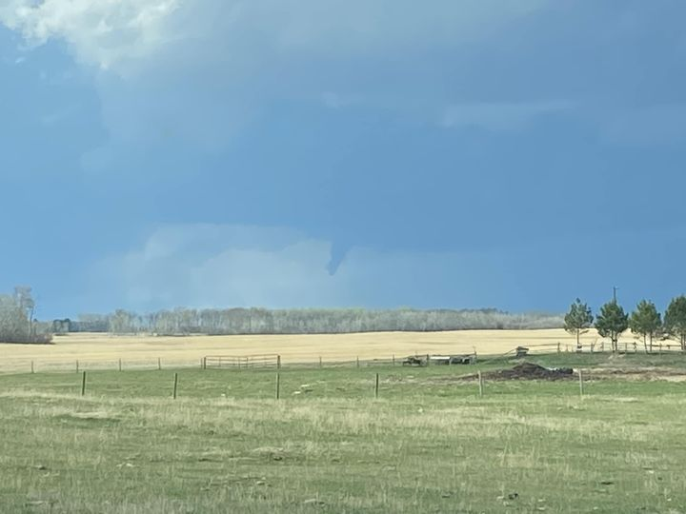Near Oakner Douglas Caldwell https://www.facebook.com/groups/605744407196622/posts/899026944535032/?__cft__[0]=AZWeHYzyIr5EdfM1RP3LBx8gWBDuV8RJohMgRthiHRxJAr3mP9jmgqFD35hjkHeYZFH8rKu1yAXgmaIZM5x0hjV1Q5aTYFoz_7MZx_-ijU1a6npJ4fiWC9DbmUynznWHCGJ1z0Jmys7qv9952phgxzXFCasLym9BglhepNj626SV6qQfHw_JbD893HBMEOBJPC8&__tn__=%2CO%2CP-R

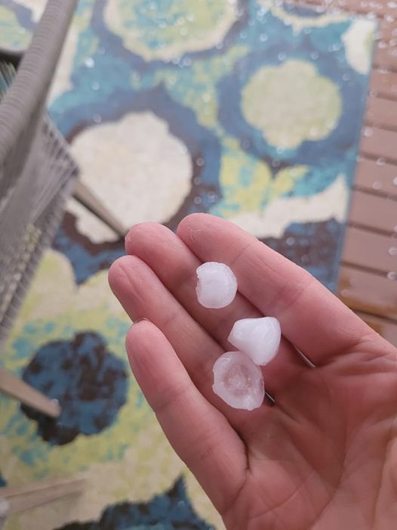Lorna Knight
·
Hail in Portage 6:30pm
https://www.facebook.com/groups/605744407196622/posts/899085914529135/?__cft__[0]=AZUWFtCunxjhsWzrlaDTQx2ZJbFlO_JfYTRgLjl0inwYLuZctkDjd2N1gO8C89prMHHG3CVb9LGHPnNzHj-MjU3MjRLZywMz2S1xWz9kDxRLf19ZJb8nSGlMgb41CBK-XXfhzs4hZjmc3wyzYPAEJ7-NmRqDY21u5wzo1cXucRnzqWYoBUHPYYDZ-vN2Vz1QvOE&__tn__=%2CO%2CP-R

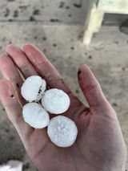This fell north of Moosomin just as it was starting. Summer Dawn
https://www.facebook.com/westmanstormchasers/posts/pfbid03b6ZJZHWPToGgfsDUqEetjV4UTMBPTjS8qYAwhRBU7YWopvZMVsJhwmxFwsGxREbl?comment_id=960019128443667&__cft__[0]=AZVuJw-bIGoUppn7NmoR_0hTWo8sGMPua0BdM8sU3zlTctr5TsQ0pkv1Y9L9DoaYAHkfT8JEP_FkIaMzHI6PutdKeVYK_G3ne1GeCgUyHqzBFocvaUfw6XRdXC5fDy8SCYAt4lZcs07hN6vLjN_G9VBs71myg9KwHtHjR3_g0QvnrF3SC0C-NlFzYOwdN9m9I3A&__tn__=R]-R

'Unstable across the prairies': First severe weather storm of the season hits Manitoba
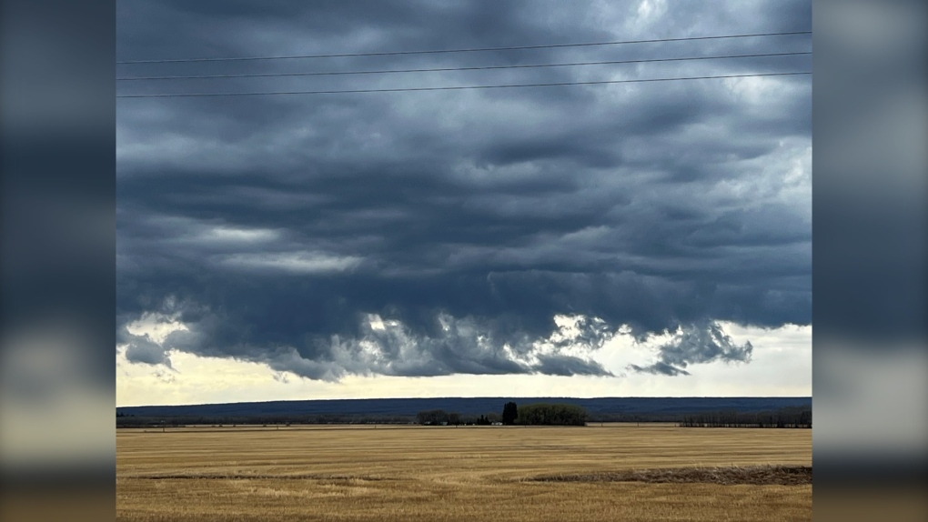Storm clouds over Duck Mountain near Ethelbert. (May 10, 2023. Source: Bonnie Derhak Semeniuk)
- Devon McKendrick
- CTVNewsWinnipeg.ca Digital Editorial Producer
Updated May 10, 2023 8:17 p.m. CDT
Published May 10, 2023 3:33 p.m. CDT
Tornado warnings, severe thunderstorm warnings and hail have been scattered throughout Manitoba Wednesday.
Western Manitoba saw three different tornado warnings from Environment and Climate Change Canada (ECCC) Wednesday afternoon starting in the R.M. of Ellice-Archie, including St-Lazare, McAuley and Manson. It was followed by the Prairie View Municipality, which included Birdtail Sioux Reserve.
The last warning happened at 4:45 p.m. for the R.M. of Oakview, which included Oak River and Rapid City.
Robyn Dyck, a meteorologist with ECCC, said there was no tornado touchdown or damage during those warnings, but she noted one funnel cloud was spotted in Saskatchewan.

Although there were no tornados, she said severe thunderstorm warnings brought strong wind, hail and rain to parts of Manitoba, including in Winnipeg.
"The largest (hail) we had reports of was about one and half (inch) hail size and that was in McGregor, Man. Even the Winnipeg Airport here, they reported about an inch in size."
Roughly ping pong size hail found in McGregor, Man. (May 10, 2023. Source: Violet Wilson)
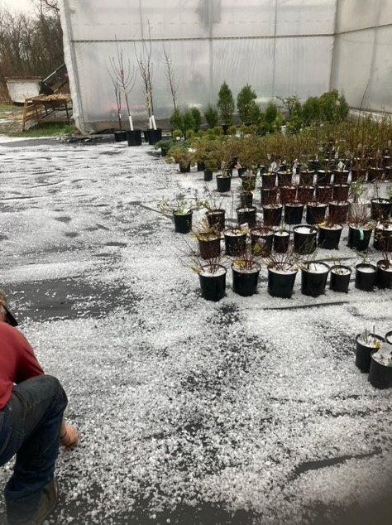Hail seen in the Parkland area of Manitoba. It came after severe thunderstorm and tornado warnings in western Manitoba. (May 10, 2023. Source: Brock Birss)
Dyck said there is a second round of storms are moving through the province Wednesday evening that is bringing more rain and hail. The system will eventually make its way into Ontario.
"This is sort of the last day in the last few days that have been unstable across the prairies. We had an upper level disturbance that's been slowly tracking across the southern prairies," she said. "So as of tomorrow, it looks like kind of a recovery day in terms of maybe a mix of sun and cloud, warm but not too warm."
Living in the prairies, Dyck said people should expect these kind of storms and weather systems sporadically until at least August.
She also noted this is the first severe weather system of the spring and is reminding people to be aware and stay inside if they see severe weather.
"Also remembering the difference between a watch and a warning. This is the first active day of the season, so remembering that a watch is there is a potential, the ingredients are there. Like, you know, you're making a recipe, all the ingredients are there for making cupcakes. Ingredients haven't been mixed together yet. The warning means that it's happening. So that means all the ingredients have been put together and now we have a cupcake."
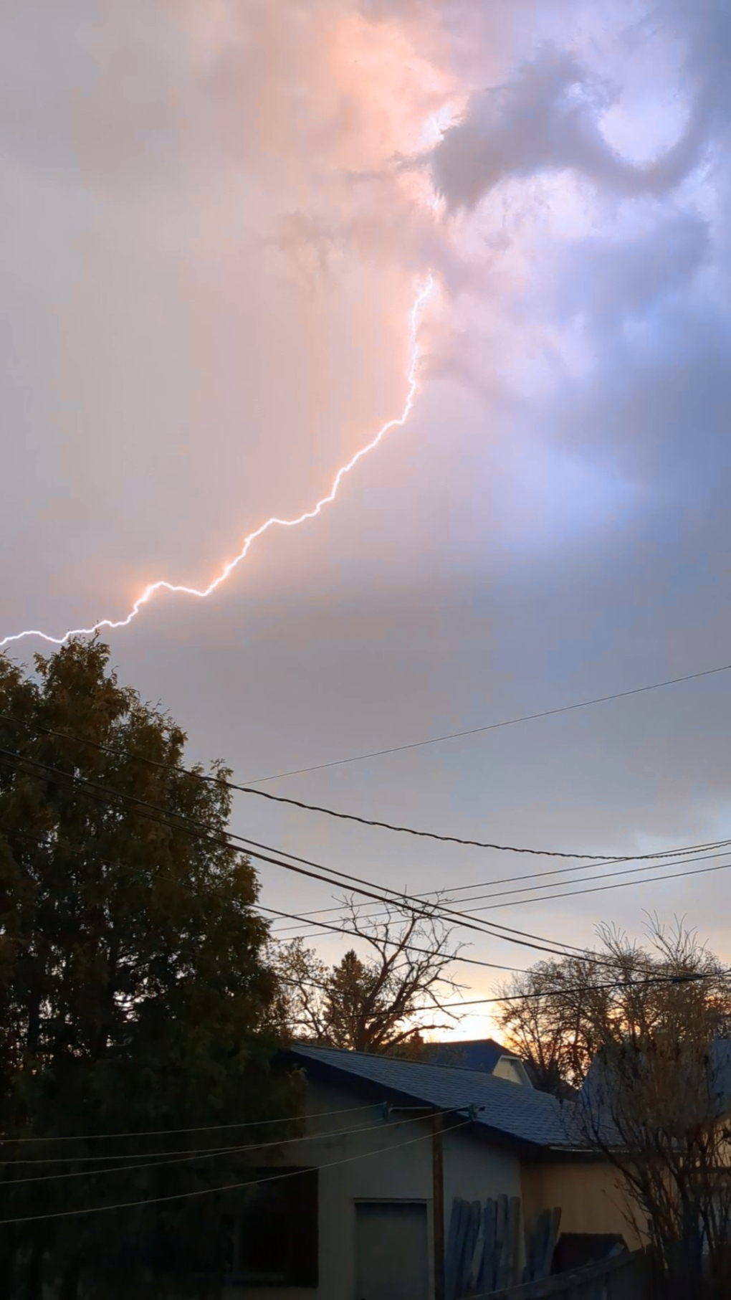A lightning strike going across the sky in Manitoba. (May 10, 2023. Source: Ross Kaulfuss)
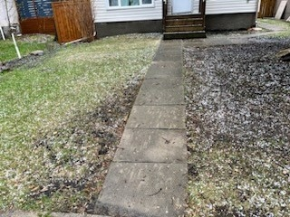Hail scattered across the ground in River Heights in Winnipeg. (May 10, 2023. Source: Chris Orbanski)
She said with the first major storm of the season, people should be more aware than normal.
Manitoba Hydro also posted on Twitter Wednesday evening saying there are a number of outages that were likely caused by the weather.

Brief, heavy storm drills southern Manitoba with rain and hail

Rainfall amounts of 16-46 mm recorded, along with pea- to golf ball-size hailstones
CBC News · Posted: May 11, 2023 9:15 AM CDT | Last Updated: May 11
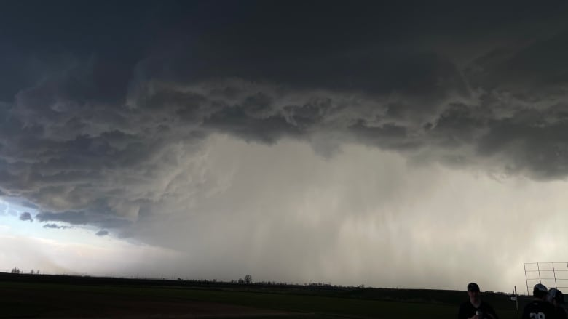
Dark, rolling clouds brought a brief but heavy downpour to southern Manitoba on Wednesday evening. This was the scene at a baseball park in Winnipeg's Charleswood neighbourhood around 7:30 p.m. (Submitted by Benjamin Bernhardt)
Skies darkened across parts of southern Manitoba for a short-lived but intense storm Wednesday night, leaving yards and fields lined with hailstones and temporary lakes.
Environment Canada meteorologist Rose Carlsen said Winnipeg saw hail ranging from pea-size to quarter-size, while Portage la Prairie, about 70 kilometres west of the city, saw golf ball-size stones.
MacGregor, a little further west, saw toonie-size hail.
As for the rain itself, the areas around Dauphin Lake seemed to be hit hardest.
Drifting River was drenched with 46 mm while Rorketon had about 29 mm. Ashville received about 27 mm and Ste Rose du Lac had about 26 mm.
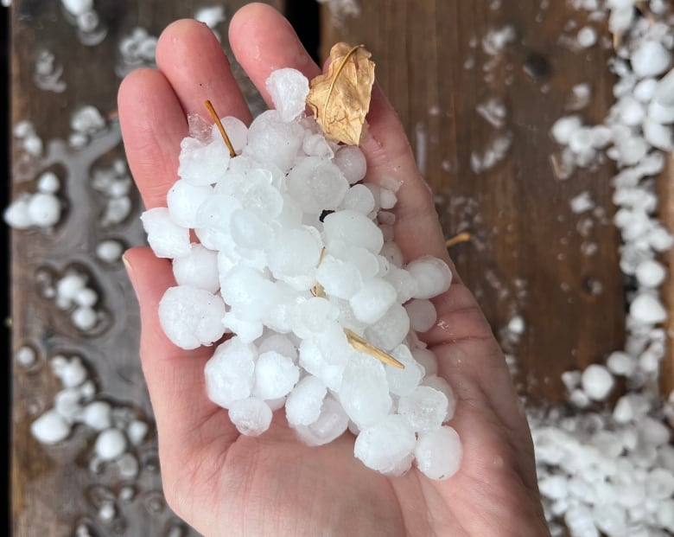
Winnipeg saw hail ranging from pea-size to quarter-size, while Portage la Prairie, about 70 kilometres west of the city, saw golf ball-size stones. (Anastasia Chipelski/CBC)
The amounts ranged in Winnipeg from about 16 mm on the west side to 23 mm in the northeast.
There were also bursts of rain south of the city with Rosa getting some 31 mm and Zhoda about 26 mm.
North of the city, in the Interlake Region, Inwood saw about 27 mm.
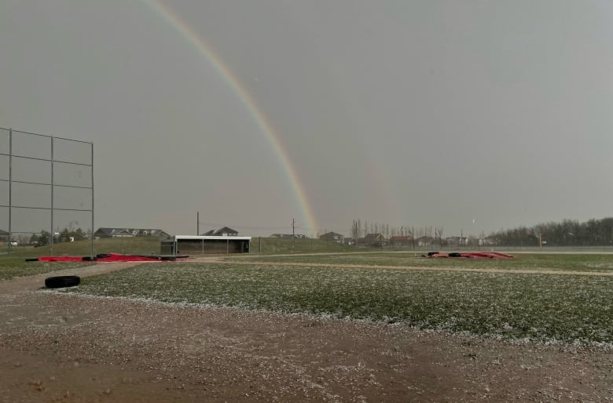
A rainbow emerges after Wednesday's storm, which left a Winnipeg baseball diamond littered with hailstones. (Submitted by Benjamin Bernhardt)

South of Neepawa, Kelli Jakubowski
https://www.facebook.com/InstantWeatherMB/posts/pfbid02hDzDLG2bD63UYst3ZHyL4KRoCHNoux3ePqS9SXKHGnKossBHwmWW3FkGdKZCH5dGl?comment_id=785093266566629&__cft__[0]=AZUdRo8uLVQMNVIW8hzizJeMBis4xatGzQuUD2cSJjiXCd0HaZG2el7kJUhVTBEelSzBkyrpwOcYKBxvwKBJzFD88idXTVpEe_JCV5ZIVIfUb0ehMWhLQJ44iH1PZKDR1tjqBd5o2QcJbYc9bd6Wr59ntZjLVt-P9JBgKA2-5ql1ycYWJS3OPhENITuBosC4NbA&__tn__=R]-R

Lorri Pedersen
tpednsSoro8lhf58061ahP0a501uhM3:0cl 1t60mya99h927 h7Ml8 45 5 ·
This is at Hallboro south of Neepawa
https://www.facebook.com/photo.php?fbid=10160688224540909&set=p.10160688224540909&type=3

